1. Tips before running the codes
(1). Citation:
When using this code, please cite the following articles:
(a). Guanghui Zhang, Xueyan Li, Yingzhi Lu, Timo Tiihonen, Zheng Chang, and Fengyu Cong. (2021). Single-trial-based Temporal Principal Component Analysis on Extracting Event-related Potentials of Interest for an Individual Subject. bioRxiv. DOI:10.1101/2021.03.10.434892
(b). Fengyu Cong, Yixiang Huang, Igor Kalyakin, Hong Li, Tiina Huttunen-Scott, Heikki Lyytinen, Tapani Ristaniemi, Frequency Response based Wavelet Decomposition to Extract Children's Mismatch Negativity Elicited by Uninterrupted Sound,Journal of Medical and Biological Engineering, 2012, 32(3): 205-214, DOI: 10.5405/jmbe.908
(c). Guanghui Zhang, Xueyan Li, and Fengyu Cong. Objective Extraction of Evoked Event-related Oscillation from Time-frequency Representation of Event-related Potentials. Neural Plasticity. DOI:10.1155/2020/8841354
(d). Lu, Y., Luo, Y., Lei, Y., Jaquess, K. J., Zhou, C., & Li, H. (2016). Decomposing valence intensity effects in disgusting and fearful stimuli: an event-related potential study. Social neuroscience, 11(6), 618-626. doi:https://doi.org/10.1080/17470919.2015.1120238

(2). Please install EEGLAB (http://sccn.ucsd.edu/eeglab/) and ERPLAB.
(3). If you want to successful run those codes, please put the cods and the EEG datasets in the same folder, as show in the following figure:
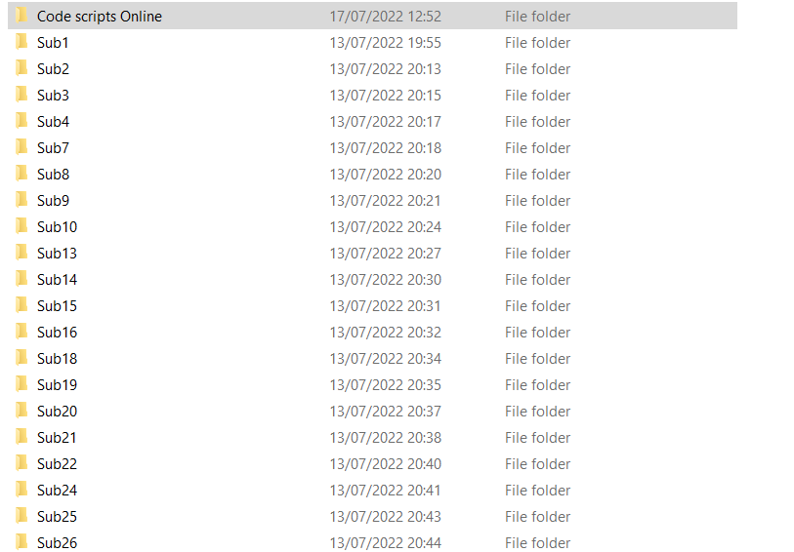

(4) Information for demo data: (a) Within-subject two-factor designed experiment (Valence and Negative-category:3[Moderate, Extreme, Neutral]* 2[Disgusting, Fear]; 20 subjects are used). (b) N2 and P2 are the ERPs of interest (190-290ms for N2 and 130-190ms for P2; FCz, FC3, FC4, Cz, C3, and C4 electrodes). (c) fs = 500ms; Epoch: -200:900ms.

